There are 20 questions in this round. Answers should be listed on the answer sheets provided and you should make two copies – one to hand in and one to keep for yourselves.
No calculators, mobile phones or smart phones are allowed.
Teams will be disqualified if they use any of these.

- What is the largest prime factor of 555555?

- A square is drawn in a circle which is enclosed in a second square. See Fig. 1. What is the ratio of the area of the smaller square to that of the larger one?

- A well-known House Builder has built 100 houses and they are to be numbered from 1 to 100. Each digit costs 80p. What change will there be out of a budget of £200 for these numbers?

- A 2-digit number is squared. When this 2-digit number is reversed and squared, the difference between the squares is also a square.
There are only two possible 2-digit numbers that this could be.
What are these possible 2-digit numbers?

- My bus fare is £1.00. I pull out a handful of change, but cannot pay the fare exactly, and I have no £2 coins. What is the maximum amount of money I can have in my hand?

- The cold tap will fill a bath in 10 minutes. The hot one will take 15 minutes. The bath will drain in 5 minutes. If the bath is full, the plug removed, but both taps are full on, how long will it take for the bath to empty?

- Janet bought some packets of biscuits at 38p each and some bottles of lemonade at 54p each. She spent £8.02. How many of each item did she buy?

- In a knockout snooker tournament fifty players entered. Fourteen were given byes into the second round, and all the others started in round 1. How many matches were played in all?

- A hobbit is 500 m due West of the bridge over a river. A black rider is 1.2 km due north of the hobbit. Given the terrain, the black rider rides twice as fast as the hobbit runs. They both head directly for the bridge. How far (in metres) is the black rider from the bridge when the hobbit gets there?

- Sally is a popular girl and everyone wants her telephone number. She tells her friends ‘all the digits from 0-9 inclusive are used, with no repeats, the leading digit is zero and the rest are in reverse alphabetical order’. What is Sally’s telephone number?

- A circle has its centre on the hypotenuse of an 8, 15, 17 triangle and touches the other two sides. See Fig. 2. What is the radius of the circle? (Leave your answer as an improper fraction in its simplest terms)

- A rectangle (not square) has its perimeter in metres equal to its area in square metres. What are its dimensions, given that they are integer metre values?

- A sports club has fifty-five members and all applied for tickets to see athletics events in the 2012 Olympics. Thirty-two applied for tickets to see the 100 metres final and of these twenty-five also applied to see the 200 metres final. Eleven did not apply for tickets to either of these events. How many in all applied for tickets to see the 200 metres final?

- Andy and Barry have a biased coin. When tossed it comes down heads with probability 40% and tails with probability 60%. Andy starts and they take turns. The first one to get a tail is the winner. What is the probability that Andy eventually wins? (leave your answer as a fraction in its lowest terms)

- An aeroplane flies from Liverpool Airport to a holiday destination airport and then makes a return flight to Liverpool. Each flight is 900 kilometres long. The aeroplane experiences a tailwind on the outward journey and a corresponding headwind on the return journey so that the flight time on the outward journey is 16 minutes less than that on the return journey. What is the average speed (in kilometres per hour) on the outward journey if it exceeds that on the return journey by 20 kilometres per hour?

- Dave often let his mind wander during an exam. At the start of a particular exam, he noticed that the time allowed for the exam (in minutes) was exactly six times the number of questions on the paper. Twenty minutes into the exam, he had answered 5 questions and noticed that the number of minutes remaining was exactly seven times the number of questions remaining to be done. How long (in minutes) was this exam?

- 1941 is an unusual number in that it has 4 digits, none of them zero and the first two digits, 19, and the last two digits, 41, are both prime numbers. Yet, the number 1941 is NOT prime (is divisible by 3 for example). What is the sum of the smallest and the largest of such numbers?

- A spider is sitting in the middle of one of the walls in my living room and a fly is resting by the side of the window on the opposite wall, 3m above the ground and 0.5m from the adjacent wall.
  - What is the shortest distance the spider would have to crawl to catch the fly?
  - The room is 5m long, 5m wide and 4m high. See Fig 3
  - Leave your answer in surd form.

- On my last birthday, my friend said to me:
  - "In 15 years' time, your age will be the square of your age 15 years ago!"
  - Can you work out how old I am?

- Look at the diagram in Fig 4 (which is not drawn to scale).
The areas of three of the triangles are shown.
What is the area of the quadrilateral APOQ ?

Fig. 1 Fig. 2

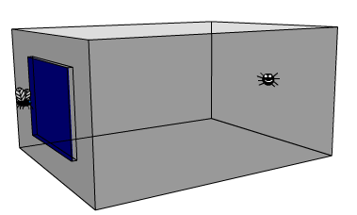
Fig 3

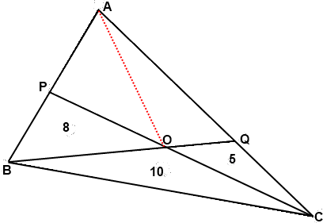
O

Fig 4

BQ and PC are straight lines which intersect at O

